Untrained unfiltered
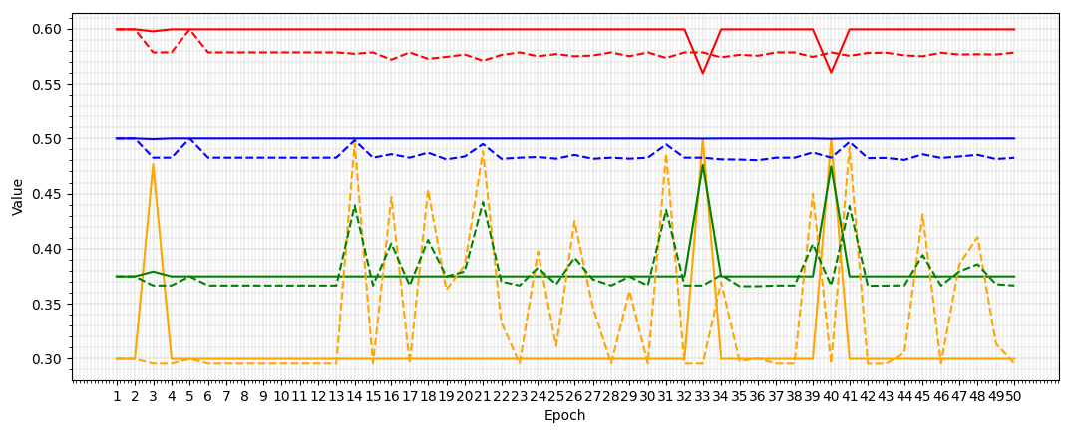
Trained unfiltered
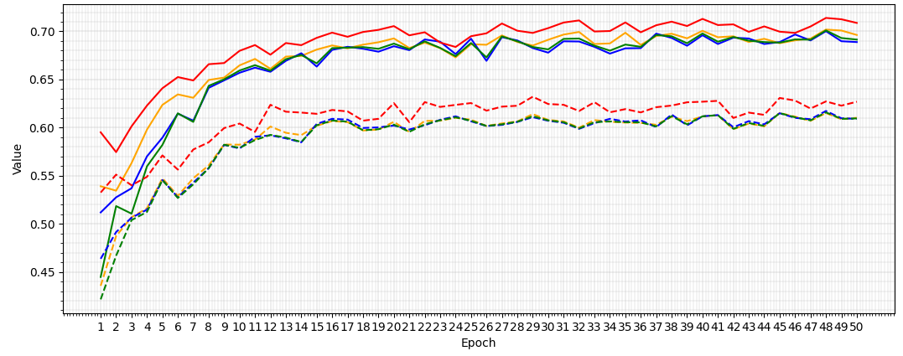
Macro-F1 first above 0.7 at epoch 48
Sample-level - Epoch 48:  Macro-F1: 0.7010  Macro-Precision: 0.7019  Macro-Recall: 0.7002  Accuracy: 0.7140 | Variant-level - Epoch 48:  Macro-F1: 0.6158  Macro-Precision: 0.6151  Macro-Recall: 0.6173  Accuracy: 0.6272
Untrained filtered
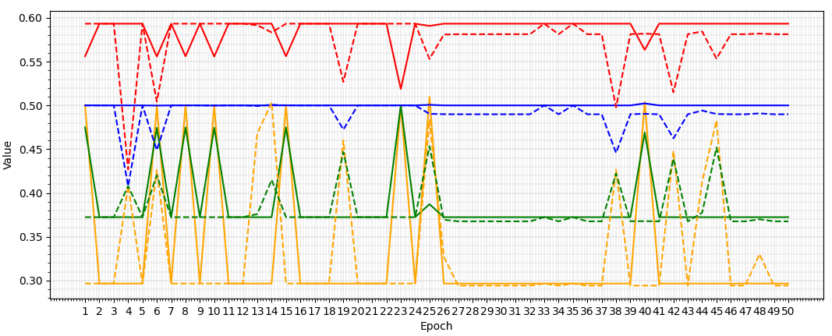
Macro-F1 never exceeded 0.7
Sample-level - Epoch 23:  Macro-F1: 0.5000  Macro-Precision: 0.5001  Macro-Recall: 0.5001  Accuracy: 0.5188 | Variant-level - Epoch 25:  Macro-F1: 0.4534  Macro-Precision: 0.4834  Macro-Recall: 0.4904  Accuracy: 0.5530
Trained filtered
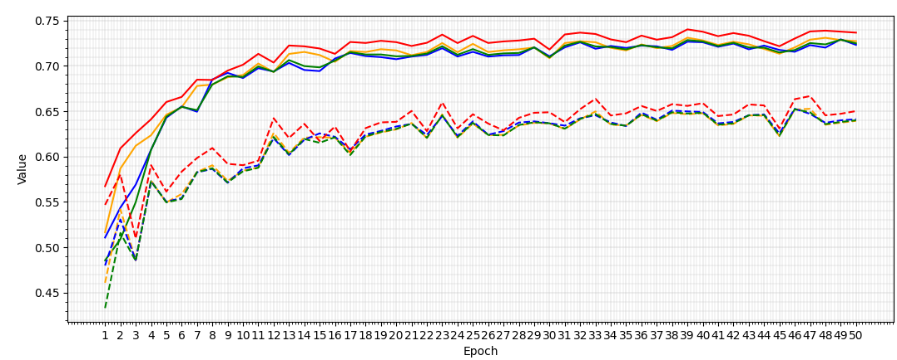
Macro-F1 first above 0.7 at epoch 13
Sample-level - Epoch 49:  Macro-F1: 0.7289  Macro-Precision: 0.7285  Macro-Recall: 0.7293  Accuracy: 0.7378 | Variant-level - Epoch 46:  Macro-F1: 0.6522  Macro-Precision: 0.6518  Macro-Recall: 0.6527  Accuracy: 0.6633

